Auto Parts Sales

(CS 6360 – 005)

Apurva Patel

Himanshu Parashar

Satwant Singh

**NOTE:** The tables are host on Satwant’s account (SXS149531).

1. **Data Requirements**
   * An auto parts sales system needs to be able to keep track of current inventory, sales transactions, and current rentals. It also needs to keep track of the registered users, employees, and store locations.
   * There can be multiple store locations. Each location has a unique id, name, address, phone number, and a unique manager assigned to it.
   * Auto parts sales stores have two types of employees, salesperson and a manager. The distinction between the two is that the manager has a store that they manage and every salesperson has a manager assigned to them. Each employee has a unique id, name, address, phone, and an email. Managers do not have a manager supervising them.
   * There can be two types of customers, registered and unregistered customers. Unregistered customers can only be identified by the sales transaction they are involved in. Registered customers can be identified by their unique id. The system also keeps track of registered customers' names, addresses, phones, emails, and loyalty points. Both registered and unregistered customers can be make a sales transaction but only registered customers can rent toolkits from a store. The system also keeps track of whether a registered user is currently renting a toolkit as only 1 toolkit per customer is allowed at a time.
   * Each sales transaction that occurs in the system, has a unique id, the id of the salesperson who conducted the transaction, time, total, the id of the store location, and optionally the id of a registered customer. If a customer does not provide their customer id at the time of purchase, the sales transaction assumes they are unregistered. This is similar to presenting a rewards card at a supermarket. The transaction also keeps track of all the items purchased and their quantity and price.
   * Each rental transaction has an id of the toolkit, id of the salesperson, rent date, return deadline and an id of the registered customer. Only registered customers are allowed to rent toolkits. Each rental transaction also have flags for the registered customer to signify that the customer has an active rental. This is because the system will only allow one toolkit rental at a time. Customers can earn points for purchasing from the store and spend them to rent toolkits.
   * The system also keeps track of all inventory across all locations. Each item in the inventory has a unique id, name, description, price, available quantity, category, location, manufacturer, and a vehicle it is for.
   * The system also keeps track of different manufacturers of parts. Each manufacturer has an ID, name, address, and phone.
   * Vehicle models are also kept track of by their unique id, name, year, and description.
2. **ER Diagram**

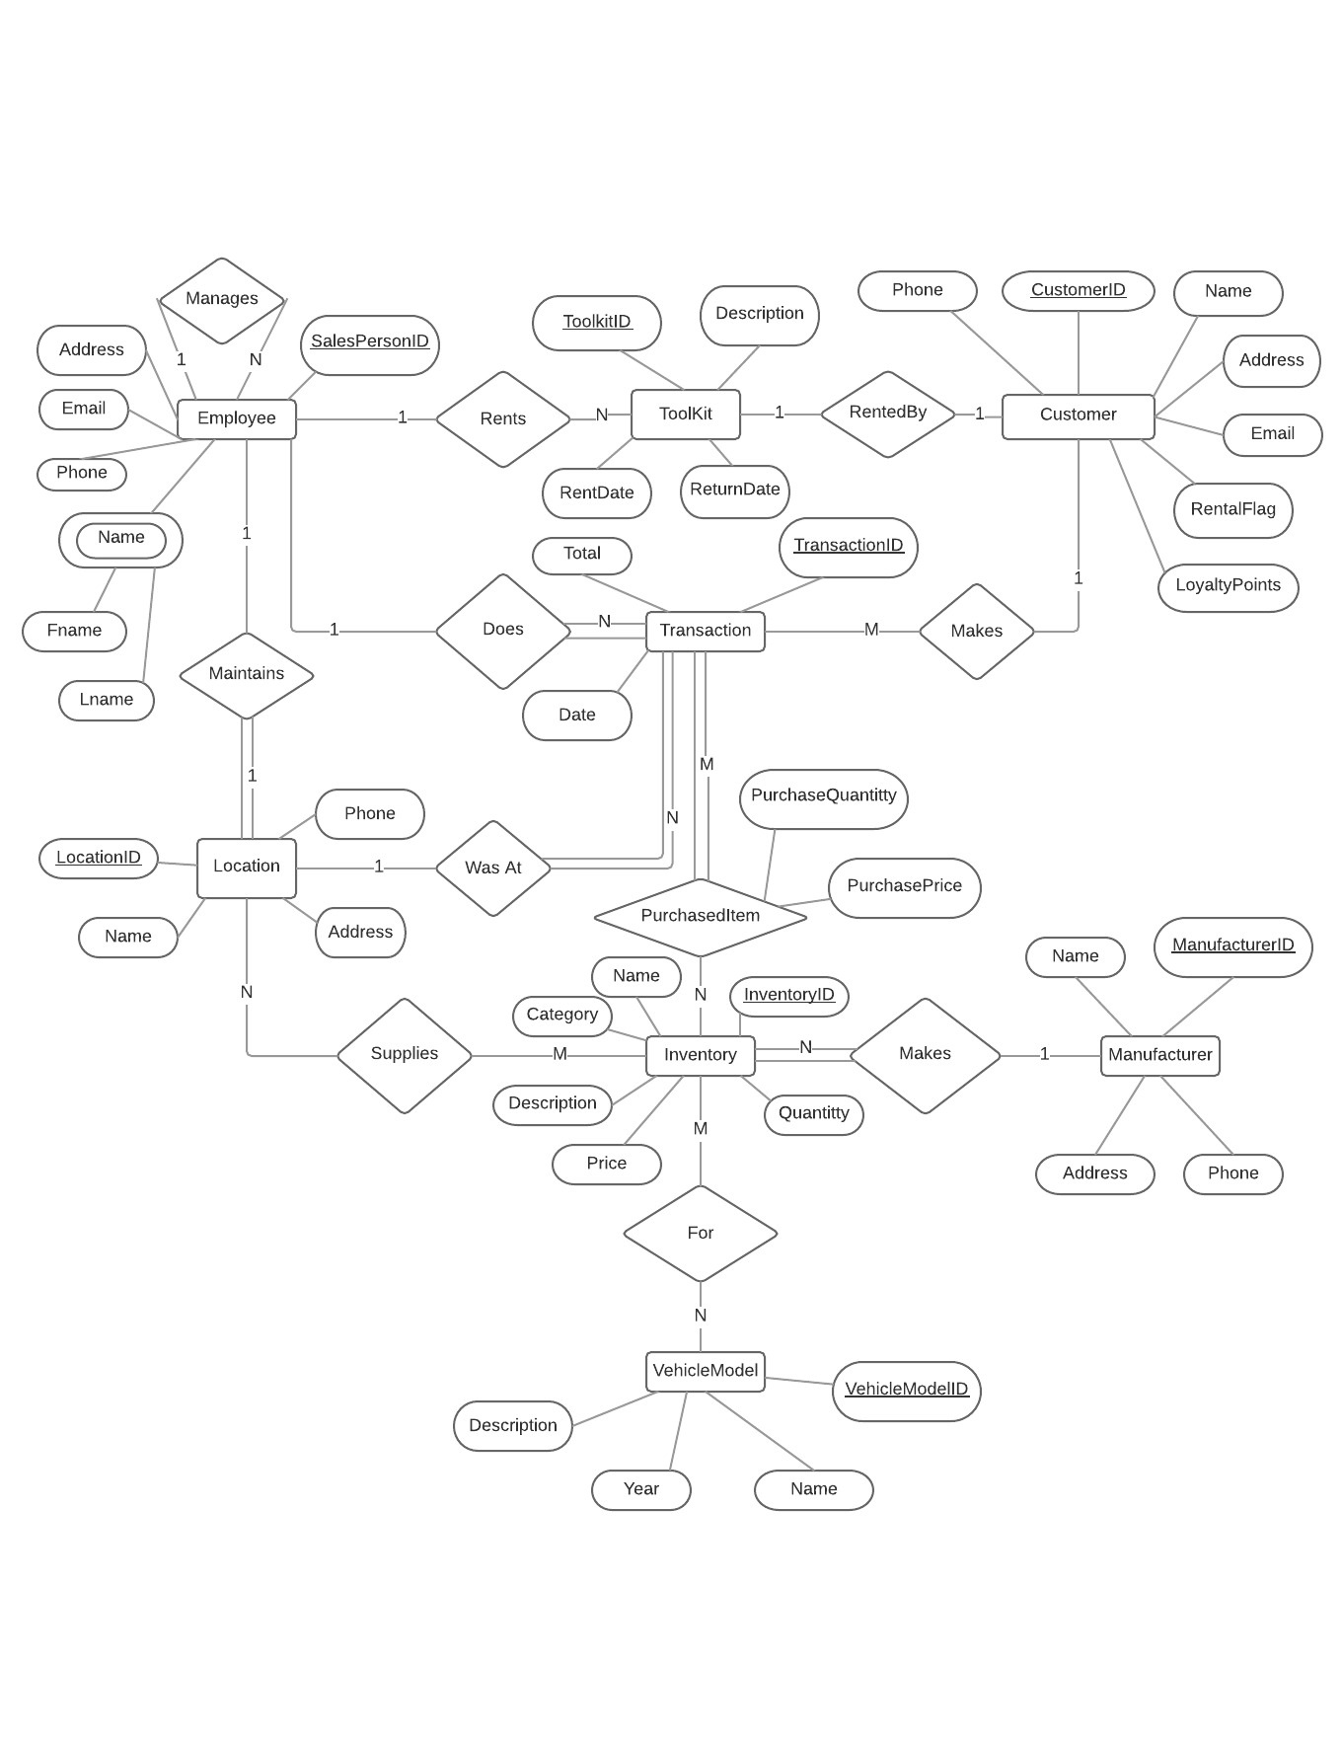

1. **Relational Schema (Already in 3NF)**

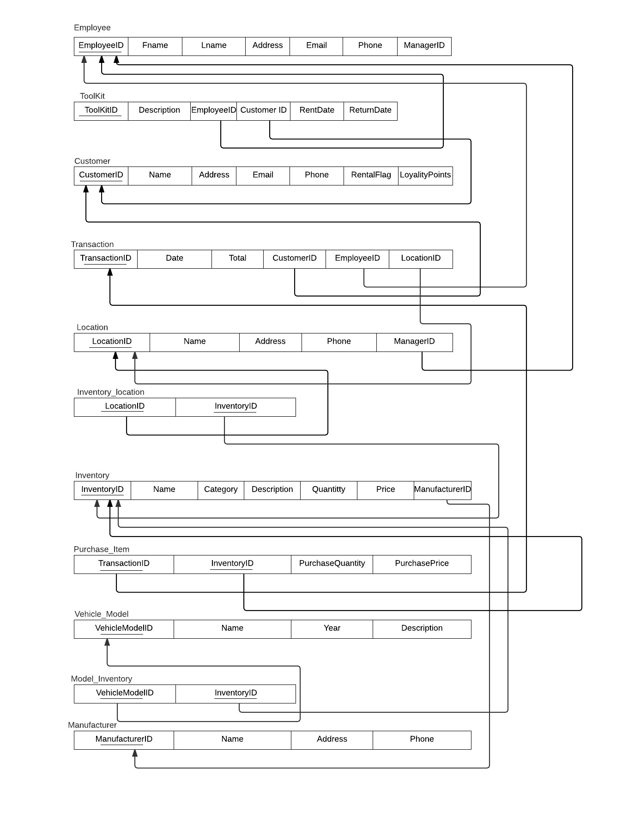

1. **Functional Dependencies**

EmployeeID -> Fname, Lname, Address, Email, Phone, ManagerID

ToolKitID -> Description, EmployeeID, CustomerID, RentDate, ReturnDate

CustomerID -> Name, Address, Email, Phone, RentalFlag, LoyalityPoints

TransactionID -> Date, Total, CustomerID, EmployeeID, LocationID

LocationID -> Name, Address, Phone, ManagerID

InventoryID -> Name, Category, Description, Quantity, Price, ManufacturerID

TransactionID, InventoryID -> PurchaseQuantity, PurchasePrice

VehicleModelID -> Name, Year, Description

ManufacturerID -> Name, Address, Phone

1. **Database Normalization Rules**

Since the initial schema does not have any transitive dependencies and every attribute is depended on the key, there does not need to be any decomposition. The only thing needed is a new table for each of the 3 M-to-N relationships with foreign keys to both entities’ primary keys as the keys of the new table.

1. **Final Relational Schema**

Due to the initial relational schema already being in 3NF, the final relational schema is the same as the initial relational schema in step 4.

1. **Create Statements (SQL)**

Create Table Employee

(

Employee_id VARCHAR2(10) NOT NULL,

Fname VARCHAR2(35),

Lname VARCHAR2(35),

Address VARCHAR2(35) DEFAULT 'NO PUBLISHER' ,

Email VARCHAR2(35),

Phone_no NUMBER(10),

Manager_id Varchar2(10),

CONSTRAINT EMPPK PRIMARY KEY (Employee_id)

);

Create Table Customer

(

Cust_id VARCHAR2(10) NOT NULL,

Name VARCHAR2(35),

Address VARCHAR2(35) DEFAULT 'NO PUBLISHER' ,

Email VARCHAR2(35),

Phone_no NUMBER(10),

Rental_Flag NUMBER(1) ,

Loyalty_Points NUMBER(10),

CONSTRAINT CUSTPK PRIMARY KEY (Cust_id)

);

Create Table Tool_kit

(

ToolKit_id VARCHAR2(10) NOT NULL,

Description VARCHAR2(35),

Employee_id Varchar2(10),

Customer_id Varchar2(10),

RentDate date,

ReturnDate date,

Constraint TOOLPK Primary Key (ToolKit_id),

Constraint ToolFK1 FOREIGN key (Employee_Id) references Employee(Employee_id) on delete set null,

constraint ToolFK2 FOREIGN key (Customer_id) references Customer(Cust_id) on delete set null

);

Create table Transaction

(

Txn_id VARCHAR2(10) NOT NULL,

Txn_date Date,

Total Number(10,2),

Customer_id Varchar2(10),

Employee_id Varchar2(10) not null ,

Location_id varchar2 (10) not null ,

Constraint TxnPK primary key (txn_id),

constraint txnFK1 FOREIGN key (Employee_id) references employee(employee_id) ,

constraint txnFK2 FOREIGN key (Customer_id) references customer(Cust_id),

constraint txnFK3 FOREIGN key (Location_id) references Location(Loc_id)

);

Create Table Location

(

Loc_id VARCHAR2(10) NOT NULL ,

name VARCHAR2(35),

Address VARCHAR2(35),

Phone Number(10),

Manager_id Varchar(10) not Null ,

constraint LocPK primary key (Loc_id),

constraint LocFK FOREIGN key (manager_id) references employee(employee_id)

);

Create table Manufacturer

(

Man_id VARCHAR2(10) NOT NULL,

Name VARCHAR2(35),

Address VARCHAR2(35) DEFAULT 'NO PUBLISHER' ,

Phone_no NUMBER(10),

constraint MANPK primary key (Man_id)

);

Create Table Vehicle_model

(

Vehicle_mod_id VARCHAR2 (10) not null ,

Vehicle_Name VARCHAR2(35) not null ,

year number(4) ,

description varchar(35),

constraint VehPK primary key (Vehicle_mod_id)

);

Create table inventory

(

Inventory_id VARCHAR2(10) NOT NULL,

Name VARCHAR2(35),

category varchar2(35),

description varchar(35),

quantity number(6),

price number(10,2),

manufacturer_id VARCHAR2(10) not null ,

constraint InvPK primary key(Inventory_id) ,

constraint INVFK FOREIGN key (manufacturer_id) REFERENCES Manufacturer(Man_id) on delete cascade

);

create table inventory_location

(

Location_id VARCHAR2(10) NOT NULL,

Inventory_id VARCHAR2(10) NOT NULL,

constraint INVLOCPK primary key (Location_id,Inventory_id),

constraint INVLOCFK1 FOREIGN key(location_id) references Location(Loc_id) on delete cascade,

constraint INVLOCFK2 FOREIGN key(Inventory_id) references Inventory(Inventory_id) on delete cascade

);

create table purchase_item

(

txn_id varchar2(10) not null ,

inventory_id varchar2(10) not null,

purchase_quantity number(6),

purchase_price number(10,2),

constraint PURCHSITMPK primary key (txn_id,inventory_id),

constraint PURCHSITMFK1 FOREIGN key (txn_id) REFERENCES transaction(txn_id) on delete cascade,

constraint PURCHSITMFK2 FOREIGN key (inventory_id) REFERENCES Inventory(Inventory_id)

);

create table Model_inventory

(

Vehicle_Model_ID varchar2(10) not null ,

inventory_id varchar2(10) not null,

constraint MODINV PRIMARY key (Vehicle_Model_ID,inventory_id),

constraint MODELINVFK1 FOREIGN key (inventory_id) REFERENCES Inventory(Inventory_id) on delete cascade,

constraint MODELINVFK2 FOREIGN key (Vehicle_Model_ID) REFERENCES Vehicle_model(Vehicle_mod_id) on delete cascade

);

**Insert Statements (SQL) to add tuples**

Insert into CUSTOMER (CUST_ID,NAME,ADDRESS,EMAIL,PHONE_NO,RENTAL_FLAG,LOYALTY_POINTS) values ('0000000000','Himanshu','123 Home Road','hm@gmail.com',9111234,0,100);

Insert into CUSTOMER (CUST_ID,NAME,ADDRESS,EMAIL,PHONE_NO,RENTAL_FLAG,LOYALTY_POINTS) values ('0000000001','George','45 Street','grg@gmail.com',9371377321,0,230);

Insert into CUSTOMER (CUST_ID,NAME,ADDRESS,EMAIL,PHONE_NO,RENTAL_FLAG,LOYALTY_POINTS) values ('0000000002','Harvey','34 Street','harv@gmail.com',663716717,0,590);

Insert into CUSTOMER (CUST_ID,NAME,ADDRESS,EMAIL,PHONE_NO,RENTAL_FLAG,LOYALTY_POINTS) values ('0000000003','Mike','43 Triangle Street','mike@gmail.com',7761361763,0,300);

Insert into CUSTOMER (CUST_ID,NAME,ADDRESS,EMAIL,PHONE_NO,RENTAL_FLAG,LOYALTY_POINTS) values ('0000000004','Tony','12 Pine Street','tony@gmail.com',921938813,0,500);

Insert into EMPLOYEE (EMPLOYEE_ID,ADDRESS,EMAIL,PHONE_NO,MANAGER_ID,FNAME,LNAME) values ('1234567890','123 Street','kevin@work.com',5556688,null,'Kevin','Bob');

Insert into EMPLOYEE (EMPLOYEE_ID,ADDRESS,EMAIL,PHONE_NO,MANAGER_ID,FNAME,LNAME) values ('1234567891','34 Road','manager@work.com',1230987,'1234567890','Satwant','Singh');

Insert into EMPLOYEE (EMPLOYEE_ID,ADDRESS,EMAIL,PHONE_NO,MANAGER_ID,FNAME,LNAME) values ('1234560092','Apt456 ,Mccallum Road,Texas','Bob123@work.com',9756058545,'1234567890','Bob','White');

Insert into EMPLOYEE (EMPLOYEE_ID,ADDRESS,EMAIL,PHONE_NO,MANAGER_ID,FNAME,LNAME) values ('1234560095','Apt983 ,Creek Road,Plano','GeorgeK3@work.com',5756058545,null,'George','Manager');

Insert into EMPLOYEE (EMPLOYEE_ID,ADDRESS,EMAIL,PHONE_NO,MANAGER_ID,FNAME,LNAME) values ('1234561075','345 ,Street x ,Richardson','KumarG3@work.com',4756058545,'1234560095','Gaurav','Kumar');

Insert into EMPLOYEE (EMPLOYEE_ID,ADDRESS,EMAIL,PHONE_NO,MANAGER_ID,FNAME,LNAME) values ('1234551099','345 ,Street x ,Richardson','KumarA3@work.com',4756058545,'1234551078','Akash','Kumar');

Insert into EMPLOYEE (EMPLOYEE_ID,ADDRESS,EMAIL,PHONE_NO,MANAGER_ID,FNAME,LNAME) values ('1234551049','898 , road g , texas','Manager4@work.com',7864534009,null,'Manager','Singh');

Insert into EMPLOYEE (EMPLOYEE_ID,ADDRESS,EMAIL,PHONE_NO,MANAGER_ID,FNAME,LNAME) values ('1234561098','7545 Collin Creek ,plano','Manager9@work.com',7737814829,null,'Marie','Brown');

Insert into EMPLOYEE (EMPLOYEE_ID,ADDRESS,EMAIL,PHONE_NO,MANAGER_ID,FNAME,LNAME) values ('1234551078','7777 Mccallum blvd ,dallas','Manager10@work.com',7374367583,null,'Jason','Black');

Insert into EMPLOYEE (EMPLOYEE_ID,ADDRESS,EMAIL,PHONE_NO,MANAGER_ID,FNAME,LNAME) values ('1234551089','7878, Street downtown 8','EmployeeApurva@work.com',9786345982,'1234551078','Apurva','Patel');

Insert into VEHICLE_MODEL (VEHICLE_MOD_ID,VEHICLE_NAME,YEAR,DESCRIPTION) values ('KOEN111337','ONE:1',2015,'Imported');

Insert into VEHICLE_MODEL (VEHICLE_MOD_ID,VEHICLE_NAME,YEAR,DESCRIPTION) values ('PORSCHE911','918',2014,'Hybrid');

Insert into VEHICLE_MODEL (VEHICLE_MOD_ID,VEHICLE_NAME,YEAR,DESCRIPTION) values ('LAMBOKING1','Sesto Elemento',2011,'Track only');

Insert into VEHICLE_MODEL (VEHICLE_MOD_ID,VEHICLE_NAME,YEAR,DESCRIPTION) values ('FERRARI012','FXX-K',2015,'Track only');

Insert into VEHICLE_MODEL (VEHICLE_MOD_ID,VEHICLE_NAME,YEAR,DESCRIPTION) values ('McLaren','P1',2014,'Limited Edition');

Insert into MANUFACTURER (MAN_ID,NAME,ADDRESS,PHONE_NO) values ('BMW1200001','BMW Corp','Street1337,Berlin,Germany',5620017654);

Insert into MANUFACTURER (MAN_ID,NAME,ADDRESS,PHONE_NO) values ('Lambo31002','Lamborghini Corp ,Volkswagen Group',' Sant''Agata Bolognese, Italy',8725961102);

Insert into MANUFACTURER (MAN_ID,NAME,ADDRESS,PHONE_NO) values ('Ferrari031','Ferrari S.P.A',' Maranello, Italy',6225961102);

Insert into MANUFACTURER (MAN_ID,NAME,ADDRESS,PHONE_NO) values ('Mclaren0p1','McLaren Automotive','Woking,surey,Britain',3225961102);

Insert into MANUFACTURER (MAN_ID,NAME,ADDRESS,PHONE_NO) values ('Chevy0p123','General Motors','Detroit, USA',9225961102);

Insert into LOCATION (LOC_ID,NAME,ADDRESS,PHONE,MANAGER_ID) values ('LOC001','Dallas','35 Collin Creek',98217827,'1234567890');

Insert into LOCATION (LOC_ID,NAME,ADDRESS,PHONE,MANAGER_ID) values ('LOC002','New York','43 Manhattan Drive',531237872,'1234560095');

Insert into LOCATION (LOC_ID,NAME,ADDRESS,PHONE,MANAGER_ID) values ('LOC003','Seattle','56 Street',8123382173,'1234551049');

Insert into LOCATION (LOC_ID,NAME,ADDRESS,PHONE,MANAGER_ID) values ('LOC004','Miami','12 Street',55464566,'1234561098');

Insert into LOCATION (LOC_ID,NAME,ADDRESS,PHONE,MANAGER_ID) values ('LOC005','San Francsico','23 Street',8329218387,'1234551078');

Insert into INVENTORY (INVENTORY_ID,NAME,CATEGORY,DESCRIPTION,QUANTITY,PRICE,MANUFACTURER_ID) values ('INV001','Wheels','Wheels','Life time warranty',10000,5000,'BMW1200001');

Insert into INVENTORY (INVENTORY_ID,NAME,CATEGORY,DESCRIPTION,QUANTITY,PRICE,MANUFACTURER_ID) values ('INV002','GearBox','Transmission','Automatic or manual',350,30000,'Lambo31002');

Insert into INVENTORY (INVENTORY_ID,NAME,CATEGORY,DESCRIPTION,QUANTITY,PRICE,MANUFACTURER_ID) values ('INV003','Brakes','Braking','Power Brakes',250,800,'Ferrari031');

Insert into INVENTORY (INVENTORY_ID,NAME,CATEGORY,DESCRIPTION,QUANTITY,PRICE,MANUFACTURER_ID) values ('INV004','HeadLights','Chasis','Xeon Lights',500,3000,'Mclaren0p1');

Insert into INVENTORY (INVENTORY_ID,NAME,CATEGORY,DESCRIPTION,QUANTITY,PRICE,MANUFACTURER_ID) values ('INV005','Turbo','Engine','Supercharger',50,70000,'Chevy0p123');

Insert into INVENTORY_LOCATION (LOCATION_ID,INVENTORY_ID) values ('LOC001','INV005');

Insert into INVENTORY_LOCATION (LOCATION_ID,INVENTORY_ID) values ('LOC002','INV004');

Insert into INVENTORY_LOCATION (LOCATION_ID,INVENTORY_ID) values ('LOC003','INV001');

Insert into INVENTORY_LOCATION (LOCATION_ID,INVENTORY_ID) values ('LOC004','INV002');

Insert into INVENTORY_LOCATION (LOCATION_ID,INVENTORY_ID) values ('LOC005','INV002');

Insert into INVENTORY_LOCATION (LOCATION_ID,INVENTORY_ID) values ('LOC005','INV003');

Insert into MODEL_INVENTORY (VEHICLE_MODEL_ID,INVENTORY_ID) values ('KOEN111337','INV001');

Insert into MODEL_INVENTORY (VEHICLE_MODEL_ID,INVENTORY_ID) values ('PORSCHE911','INV002');

Insert into MODEL_INVENTORY (VEHICLE_MODEL_ID,INVENTORY_ID) values ('LAMBOKING1','INV003');

Insert into MODEL_INVENTORY (VEHICLE_MODEL_ID,INVENTORY_ID) values ('FERRARI012','INV004');

Insert into MODEL_INVENTORY (VEHICLE_MODEL_ID,INVENTORY_ID) values ('McLaren','INV005');

Insert into MODEL_INVENTORY (VEHICLE_MODEL_ID,INVENTORY_ID) values ('LAMBOKING1','INV001');

Insert into MODEL_INVENTORY (VEHICLE_MODEL_ID,INVENTORY_ID) values ('FERRARI012','INV002');

Insert into MODEL_INVENTORY (VEHICLE_MODEL_ID,INVENTORY_ID) values ('McLaren','INV001');

Insert into TOOL_KIT (TOOLKIT_ID,DESCRIPTION,EMPLOYEE_ID,CUSTOMER_ID,RENTDATE,RETURNDATE) values ('Kit0006712','Kit of Location001',null,null,null,null);

Insert into TOOL_KIT (TOOLKIT_ID,DESCRIPTION,EMPLOYEE_ID,CUSTOMER_ID,RENTDATE,RETURNDATE) values ('Kit0006714','Kit 2 of Location001',null,null,null,null);

Insert into TOOL_KIT (TOOLKIT_ID,DESCRIPTION,EMPLOYEE_ID,CUSTOMER_ID,RENTDATE,RETURNDATE) values ('Kit0006716','Kit of Location002',null,null,null,null);

Insert into TOOL_KIT (TOOLKIT_ID,DESCRIPTION,EMPLOYEE_ID,CUSTOMER_ID,RENTDATE,RETURNDATE) values ('Kit0006715','Kit of Location003',null,null,null,null);

Insert into TOOL_KIT (TOOLKIT_ID,DESCRIPTION,EMPLOYEE_ID,CUSTOMER_ID,RENTDATE,RETURNDATE) values ('Kit0006719','Kit of Location004',null,null,null,null);

Insert into TOOL_KIT (TOOLKIT_ID,DESCRIPTION,EMPLOYEE_ID,CUSTOMER_ID,RENTDATE,RETURNDATE) values ('Kit0006710','Kit of Location005',null,null,null,null);

Insert into TRANSACTION (TXN_ID,TXN_DATE,TOTAL,CUSTOMER_ID,EMPLOYEE_ID,LOCATION_ID) values ('txnLoc1120',to_date('02-DEC-15','DD-MON-RR'),40000,'0000000000','1234567891','LOC001');

Insert into TRANSACTION (TXN_ID,TXN_DATE,TOTAL,CUSTOMER_ID,EMPLOYEE_ID,LOCATION_ID) values ('txnLoc1121',to_date('06-DEC-15','DD-MON-RR'),50000,'0000000001','1234560092','LOC001');

Insert into TRANSACTION (TXN_ID,TXN_DATE,TOTAL,CUSTOMER_ID,EMPLOYEE_ID,LOCATION_ID) values ('txnLoc2120',to_date('25-NOV-15','DD-MON-RR'),35000,'0000000002','1234551099','LOC002');

Insert into TRANSACTION (TXN_ID,TXN_DATE,TOTAL,CUSTOMER_ID,EMPLOYEE_ID,LOCATION_ID) values ('txnLoc2100',to_date('04-DEC-15','DD-MON-RR'),71000,'0000000003','1234561075','LOC002');

Insert into TRANSACTION (TXN_ID,TXN_DATE,TOTAL,CUSTOMER_ID,EMPLOYEE_ID,LOCATION_ID) values ('txnLoc1123',to_date('21-OCT-15','DD-MON-RR'),2900,'0000000004','1234551089','LOC005');

Insert into TRANSACTION (TXN_ID,TXN_DATE,TOTAL,CUSTOMER_ID,EMPLOYEE_ID,LOCATION_ID) values ('txnLoc3110',to_date('24-NOV-15','DD-MON-RR'),5700,null,'1234551089','LOC005');

Insert into TRANSACTION (TXN_ID,TXN_DATE,TOTAL,CUSTOMER_ID,EMPLOYEE_ID,LOCATION_ID) values ('txnLoc3111',to_date('28-OCT-15','DD-MON-RR'),88000,null,'1234551089','LOC005');

Insert into TRANSACTION (TXN_ID,TXN_DATE,TOTAL,CUSTOMER_ID,EMPLOYEE_ID,LOCATION_ID) values ('txnLoc2125',to_date('08-DEC-15','DD-MON-RR'),93000,null,'1234561075','LOC002');

Insert into PURCHASE_ITEM (TXN_ID,INVENTORY_ID,PURCHASE_QUANTITY,PURCHASE_PRICE) values ('txnLoc1120','INV001',8,100045);

Insert into PURCHASE_ITEM (TXN_ID,INVENTORY_ID,PURCHASE_QUANTITY,PURCHASE_PRICE) values ('txnLoc1121','INV002',1,89000);

Insert into PURCHASE_ITEM (TXN_ID,INVENTORY_ID,PURCHASE_QUANTITY,PURCHASE_PRICE) values ('txnLoc2120','INV003',3,45000);

Insert into PURCHASE_ITEM (TXN_ID,INVENTORY_ID,PURCHASE_QUANTITY,PURCHASE_PRICE) values ('txnLoc2100','INV004',5,87000);

Insert into PURCHASE_ITEM (TXN_ID,INVENTORY_ID,PURCHASE_QUANTITY,PURCHASE_PRICE) values ('txnLoc3110','INV003',1,50501);

Insert into PURCHASE_ITEM (TXN_ID,INVENTORY_ID,PURCHASE_QUANTITY,PURCHASE_PRICE) values ('txnLoc3111','INV003',2,43435);

Insert into PURCHASE_ITEM (TXN_ID,INVENTORY_ID,PURCHASE_QUANTITY,PURCHASE_PRICE) values ('txnLoc2125','INV005',7,77700);

Insert into PURCHASE_ITEM (TXN_ID,INVENTORY_ID,PURCHASE_QUANTITY,PURCHASE_PRICE) values ('txnLoc1123','INV005',10,165000);

1. **Stored Procedures (PL/SQL)**

---PROCEDURE FOR TRANSACTION (GIVE LOYALTY POINTS FOR TRANSACTION AND UPDATE INVENTORY)---

create or replace PROCEDURE SALES_TRANSACTION(INPUTTXNID IN TRANSACTION.TXN_ID%TYPE)

AS

CUSID CUSTOMER.CUST_ID%TYPE;

INVENTORYID INVENTORY.INVENTORY_ID%TYPE;

ITEM_TABLE PURCHASE_ITEM%ROWTYPE;

QUANTY INVENTORY.QUANTITY%TYPE;

POINTS NUMBER ;

CURSOR INVNTRYUPDT

IS

SELECT * FROM PURCHASE_ITEM WHERE TXN_ID = INPUTTXNID ;

BEGIN

OPEN INVNTRYUPDT;

LOOP

FETCH INVNTRYUPDT INTO ITEM_TABLE;

EXIT WHEN (INVNTRYUPDT%NOTFOUND);

SELECT QUANTITY INTO QUANTY FROM INVENTORY WHERE INVENTORY_ID=ITEM_TABLE.INVENTORY_ID ;

IF (ITEM_TABLE.TXN_ID = INPUTTXNID AND ITEM_TABLE.PURCHASE_QUANTITY <= QUANTY )

THEN

UPDATE INVENTORY SET QUANTITY = (QUANTITY - ITEM_TABLE.PURCHASE_QUANTITY) WHERE INVENTORY_ID=ITEM_TABLE.INVENTORY_ID ;

END IF;

END LOOP;

CLOSE INVNTRYUPDT;

SELECT TOTAL INTO POINTS FROM TRANSACTION WHERE TXN_ID = INPUTTXNID ;

SELECT CUSTOMER_ID INTO CUSID FROM TRANSACTION WHERE TXN_ID = INPUTTXNID;

UPDATE CUSTOMER SET LOYALTY_POINTS = LOYALTY_POINTS + POINTS where CUST_ID = CUSID ;

END;

--- TESTING THE ABOVE PROCEDURE ----

set SERVEROUTPUT ON

begin SALES_TRANSACTION('txnLoc2100'); end;

---PROCEDURE FOR RENTING A TOOL KIT (GIVE A START AND THE LAST DAY TO RETURN DATE FOR A GIVEN TOOLKIT FOR A CUSTOMER AND MARK CUSTOMER FOR HAVING A TOOLKIT RENTED)-----

create or replace PROCEDURE RENT_TOOLKIT(INPUTKITID IN TOOL_KIT.TOOLKIT_ID%TYPE ,INPUTEMPLOYEEID IN EMPLOYEE.EMPLOYEE_ID%TYPE ,INPUTCUSTOMERID IN CUSTOMER.CUST_ID%TYPE )

AS

CUS_ID CUSTOMER.CUST_ID%TYPE;

RENTFLAG CUSTOMER.RENTAL_FLAG%TYPE;

POINTS CUSTOMER.LOYALTY_POINTS%TYPE;

BEGIN

SELECT CUSTOMER_ID INTO CUS_ID FROM TOOL_KIT WHERE TOOLKIT_ID = INPUTKITID;

SELECT RENTAL_FLAG INTO RENTFLAG FROM CUSTOMER WHERE CUST_ID= INPUTCUSTOMERID;

SELECT LOYALTY_POINTS INTO POINTS FROM CUSTOMER WHERE CUST_ID=INPUTCUSTOMERID;

IF (CUS_ID IS NULL AND RENTFLAG = 0 AND POINTS >= 100)

THEN

UPDATE TOOL_KIT SET RENTDATE= SYSDATE , CUSTOMER_ID = INPUTCUSTOMERID , EMPLOYEE_ID =INPUTEMPLOYEEID,RETURNDATE =trunc(sysdate)+POINTS WHERE TOOLKIT_ID=INPUTKITID;

UPDATE CUSTOMER SET RENTAL_FLAG = 1 WHERE CUST_ID = INPUTCUSTOMERID ;

END IF ;

END ;

--- TESTING THE ABOVE PROCEDURE ----

set serveroutput on

begin RENT_TOOLKIT('Kit0006712','1234567891','0000000003');end;

---PROCEDURE FOR RETURN TOOL KIT (RETURN TOOLKIT AND SUBTRACT LOYALTY POINTS)----

create or replace PROCEDURE RETURN_TOOLKIT(INPUTKITID IN TOOL_KIT.TOOLKIT_ID%TYPE)

AS

CUSID CUSTOMER.CUST_ID%TYPE;

RENTDAYS NUMBER;

BEGIN

SELECT CUSTOMER_ID INTO CUSID FROM TOOL_KIT WHERE TOOLKIT_ID = INPUTKITID;

SELECT ROUND(SYSDATE - TK.RENTDATE)INTO RENTDAYS FROM TOOL_KIT TK WHERE TK.TOOLKIT_ID = INPUTKITID;

UPDATE CUSTOMER SET RENTAL_FLAG=0,LOYALTY_POINTS=LOYALTY_POINTS-RENTDAYS WHERE CUST_ID=CUSID;

UPDATE TOOL_KIT SET RENTDATE = null , CUSTOMER_ID = null , EMPLOYEE_ID = null ,ReturnDate = null where ToolKit_id =INPUTKITID;

END;

--- TESTING THE ABOVE PROCEDURE ----

set serveroutput on

begin RETURN_TOOLKIT('Kit0006712');end;

---PROCEDURE FOR REVENUE REPORT (GENERATE REVENUE REPORT FOR GIVEN DATES) ---

create or replace PROCEDURE Revenue_Report(from_date in Date,till_date in Date)

as

txn_total NUMBER;

txn_count number;

thistxn transaction%ROWTYPE;

Cursor txns is select * from TRANSACTION where TXN_DATE between from_date and till_date;

begin

select sum(total),count(*) into txn_total,txn_count from TRANSACTION where TXN_DATE between from_date and till_date;

open txns;

loop

fetch txns into thistxn;

exit when (txns%NOTFOUND);

dbms_output.put_line('TransactionID:' || thistxn.txn_id ||'Date:'|| thistxn.txn_date||'Price:$'||thistxn.total);

end loop;

close txns;

dbms_output.put_line('In total '|| txn_count||' transactions between '||from_date||' and '||till_date||'generating revenue of $'||txn_total);

end;

--- TESTING THE ABOVE PROCEDURE ----

set serveroutput on

begin Revenue_Report('01-OCT-15','31-DEC-15');end;